**BASICS OF DIRECT CURRENT CIRCUITS (DC)**

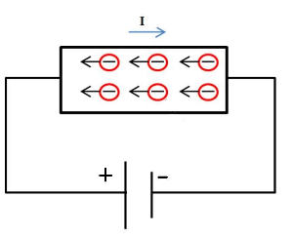**Definition on current**

Electric current is the rate of the flow of electrons passing through the cross-section of a wire during a specific time. Although electrons are moving from higher potential to lower potential, the direction of current is opposite. (This is a very old misunderstanding which is not corrected)

$I=\frac{Q}{t}$**, $\left[I\right]=\frac{[Q]}{[t]}=\frac{C}{s}=A$ (amper)**

**DC current**

In DC current (Direct Current), the electrons move from an area of negative charge to an area of positive charge without changing direction. This is unlike [alternating current](https://www.electrical4u.com/alternating-current/) (AC) circuits where current can flow in both directions.

**Definition of resistance**

Resistance is an electric quantity that measures how the device or material reduces the electric current flow through it. The SI-unit of resistance is **ohm Ω**

**Resistance of wire**

$R= ρ\frac{l}{A}$ where $ρ$ = resistivity of wire material

l = length of wire

A = cross-sectional area of wire

**Temperature dependence of the resistivity materials**

$ρ=ρ_{0}[1+α\left(T-T_{0}\right)]$ where $ρ_{0}$ = resistivity of wire material at the temperature T0

α = temperature coefficient of resistivity

**Resistance and Ohm’s law**

Ohm's law: The voltage across a conductor is directly proportional to the current flowing through it.

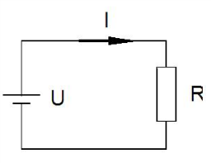

$$U=RI$$

**Emf E (electromotive force) and internal resistance of a battery**

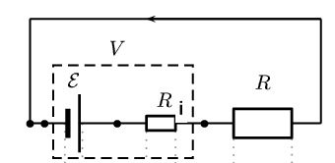

E = Ri·I + U

where E = electromotive force (emf)

Ri = internal resistance

U = terminal voltage

(In some cases (R >> Ri) we can think that the emf is an ideal. An ideal emf device has no internal resistance.)

**Resistors in series and Parallel**

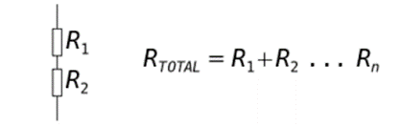

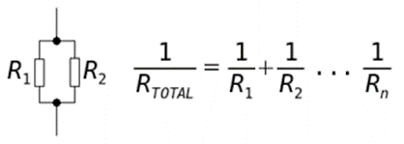

**Kirchhoff’s rules**

**The loop rule**: The sum of the potential differences encountered in a round-trip around any closed loop in the circuit is zero. (or the sum of emfs = the sum of other potential differences)

**The point (junction) rule:** The sum of the currents toward a branch point is equal to the sum of the currents away from the same branch point.

Loop 1: E1 = R1I1 + R3I3

Loop 2: E2 = R2I2 + R3I3

Loop 3: E1-E2 = R1I1 –R2I2

Branch point A: I1 + I2 = I3

Branch point B: I3 = I1 + I2

Notice that we get only three independent equations from this example:

E1 = R1I1 + R3I3

E2 = R2I2 + R3I3

I1 + I2 = I3

**Electric energy and power**

The power dissipated as heat in a resistor is $P=UI=I^{2}R= \frac{U^{2}}{R}$